**Aero2Astro**

**PPYOLO V1 and V2**

**Report**

**By**

**Anshul Singh**

**Research intern-Inspect**

**PPYolo V1**

**Architecture:**

**Backbone:**

DarkNet-53 backbone is replaced by ResNet50-vd in PP-YOLO. some convolutional layers in ResNet50-vd were replaced by deformable convolutional layers(DCN). Adding DCN won’t hamper the overall performance but too many DCN layers will greatly increase infer time. Therefore, in order to balance the efficiency and effectiveness, only 3 * 3 convolution layers were replaced in the last stage with DCNs. We denote this modified back-bone are denoted as C3,C4,C5.

**Detection Neck**

The FPN is used to build an feature pyramid with lateral connections between feature maps.

**Detection Head:**

Detection head consists of two convolutional layers. A 3*3 convolutional followed by an 1*1 convolutional layer is adapted to get the final predictions.

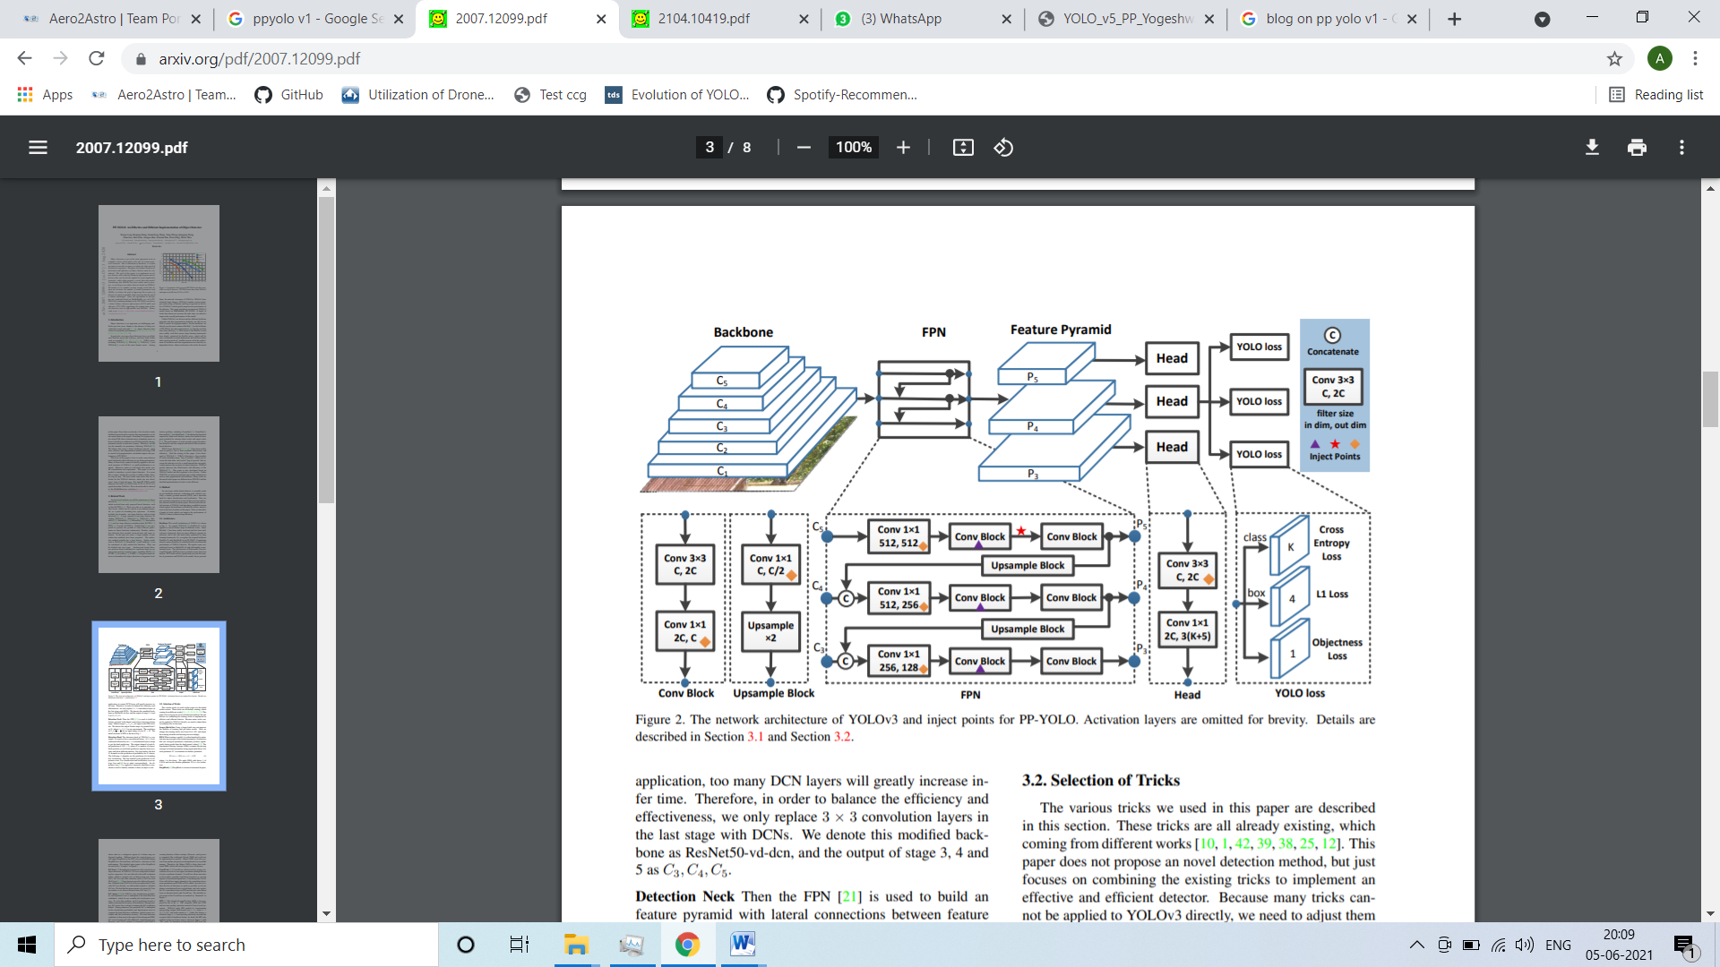

**Selection of Tricks**

The various tricks we used in this paper are described in this section.

1. Larger Batch Size
2. EMA(Exponential moving average)
3. Dropblock
4. IOULoss(Intersection over union)
5. IOUAware
6. Grid sensitive
7. CoordConv
8. SPP
9. Pretrain model

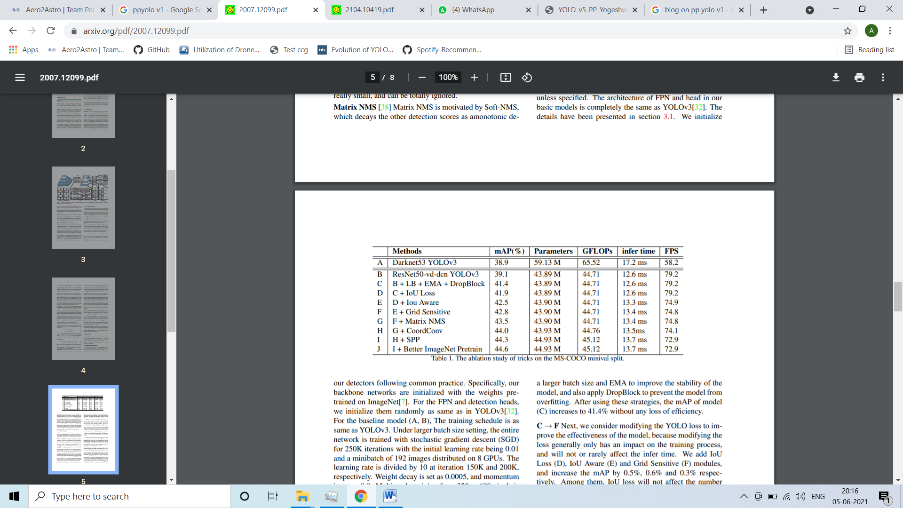

**PPYolo V2**

**Baseline model:**

Backbone of PPTOLO v1 was replaced by ResNet50-vd.

After that a total of 10 tricks which can improve the performance of YOLOv3 almost without losing efficiency are added to YOLOv3,

These are:

1. Deformable Conv
2. SSLD
3. CoordConv
4. Drop-Block
5. SPP and so on.

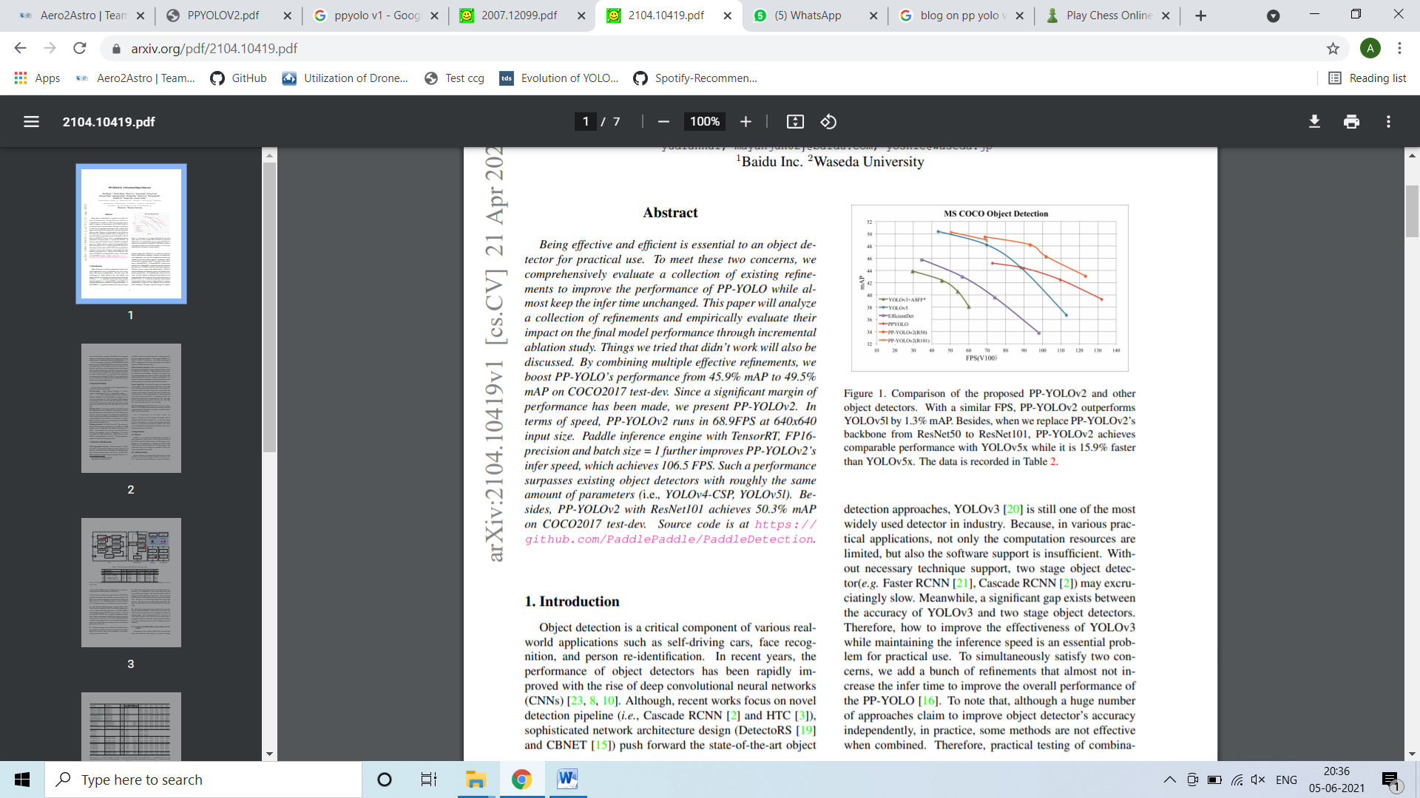

**Selection of Refinements**

Following refinements were introduced in PPYOLO V1 model that lead to v2:

1. Path aggregation network
2. Mish Activation function
3. Larger input size
4. IOU aware branch

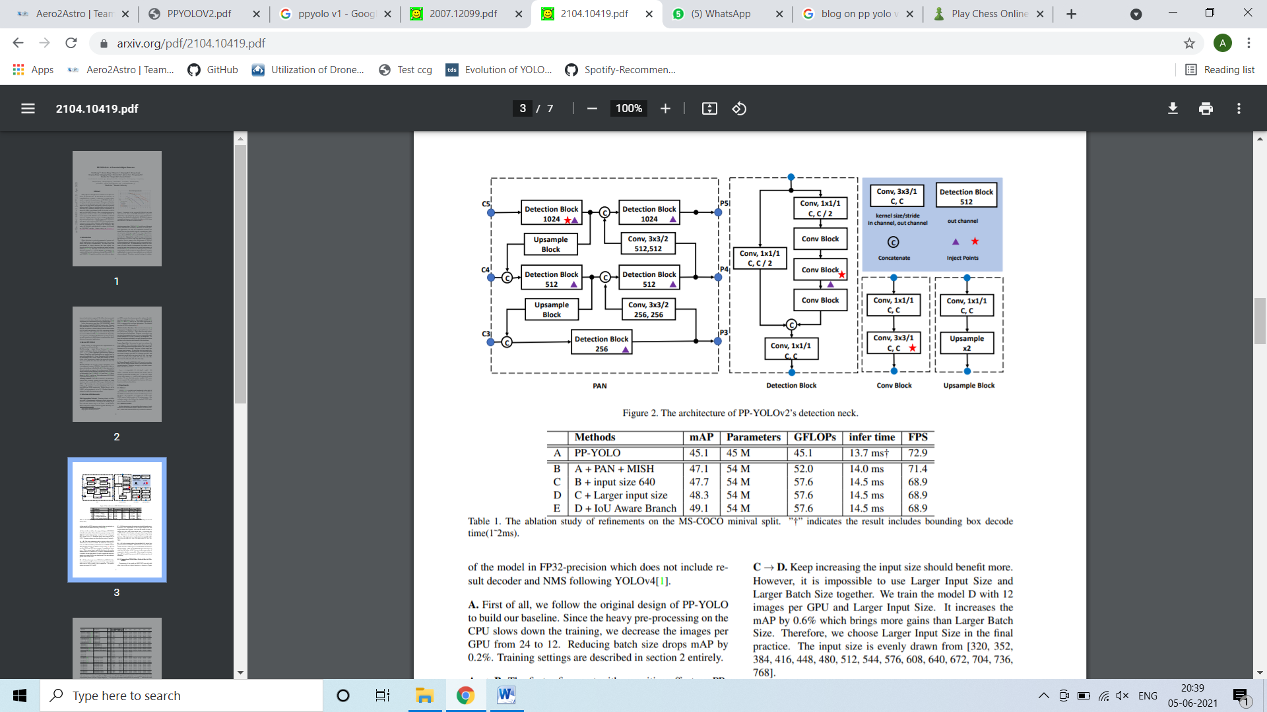

**Conclusions**

PP-YOLOv2 achieves a better balance between speed and accuracy than other famous detectors, such as YOLOv4 and YOLOv5.